Virtual electronics lab extravaganza

Science of Acoustics Name __ Darsh Thakker _________________

Special COVID-19 virtual electronics lab extravaganza

Many sections of this course do an “Ohm’s Law” lab activity where we get out batteries, variable resistors, and multimeters (these are meters that can measure current, voltage, and resistance), and do some quick measurements. Absent that possibility, we’ll use my favorite virtual simulator and throw in some extra fun.

Visit: https://phet.colorado.edu/en/simulation/circuit-construction-kit-dc-virtual-lab

Why bother with electronics in this course? Some of you have taken or are about to take a version of electronics either in Science and Math or elsewhere, but we can’t assume everyone has been exposed to the material. Also, some activity about voltage, current, and the like will make it easier to discuss magnetic induction and transducers relevant to audio like microphones and speakers. Please follow these instructions and answer the questions.

Setting up a simple resistor circuit

Once you’re in the program, drag a battery, some wires, and a resistor on the screen and make this circuit:

Q1: This battery is meant to look like a Duracell, where the “copper” side is the (+) terminal. What do you think the blue dots in this picture represent?
It represent the flow of electrons . 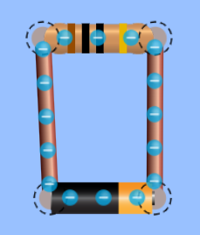

You can click on either the battery (changing its voltage) or the resistor (changing its resistance – notice the colors on it change to agree with standard codes: brown = 1, black = 0, next black = x10⁰).

The flow of current is what is being animated.
Q2: What happens to this flow if you increase the resistance? On increasing the resistance and keeping voltage constant, the current reduces. What happens if you increase the voltage? On increasing voltage, the current increases

You’ll want to become familiar with the tools used to measure current and voltage. Voltage is measured with (surprise) a voltmeter and current is measured with an ammeter. The units of voltage are Volts (V), and the units of current are Amperes or “amps” for short (A). Resistance is measured in ohms (written as Ω, or “omega”). Letters used for voltage (V) and resistance (R) are predictable. Current is labeled I.

Check out these tools:

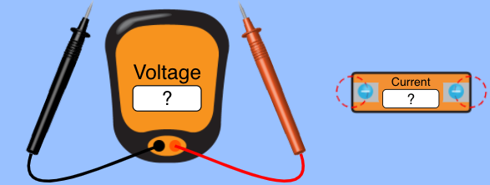
(Voltmeter on the left, ammeter on the right)

We would use a multimeter in class that performs both these functions (and it somewhat resembles the voltmeter), but I like how these are done in the sim because you have to understand the correct hookups.

Voltmeters technically measure a voltage difference between two points (chosen by the probes – if you get a negative number, you placed the red probe at the lower voltage point). Voltmeters are connected in parallel, that is, they don’t go directly in the flow of current. Ammeters are connected in series, that is, if you want to find current in a loop, you have to break the loop you’re interested in and insert the ammeter. In the simulation, left clicking on a junction lets you split it.

Here is our simple circuit with sample meters attached:
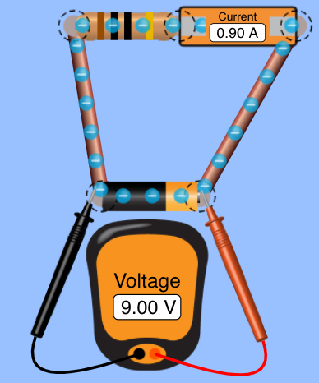

When you set this up, you’ll move the voltmeter probes to be across the resistor.

Activity – single resistor circuit.

Set the above up with the voltmeter probing the ends of the resistor. By clicking on the resistor, change its value and try at least six values for the resistance. Fill in the table.

Resistance (Ω) | V across resistor (V) | I: Current (A) | I x R
10 | 10 | 1 | 10
15 | 30 | 2 | 30
20 | 40 | 2 | 40
25 | 25 | 1 | 25
30 | 15 | 0.5 | 15
40 | 20 | 2 | 20

Q3: What patterns do you observe in the data? Anything surprising?
There is nothing surprising, all I can see is the pattern following the ohms law whereby V = I x R
Q4: If you graphed the resistance on the x-axis of a graph and the current on the y-axis, what’s the shape you’d expect, roughly, and why?

The graph is not a straight line, in fact it would curve and with a negative gradient

Ohm’s Law says for certain substances, the voltage you put across a conductor is proportional to the current that you get (the rule V = IR you often read comes from the definition of resistance, and Ohm’s Law says the R is a constant.)

Now, light bulbs in the real world are NOT what we call “Ohmic.” If you put more current through a light bulb filament, it gets hotter and its resistance goes up. The simulator does NOT assume this. Simulator bulbs are useful, though, because they glow brighter with increased current, which helps us visualize. Think about these single bulb, series, and parallel circuits shown. (I included a switch so I can turn this “on” and “off” easily.)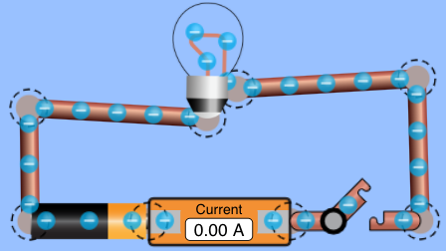
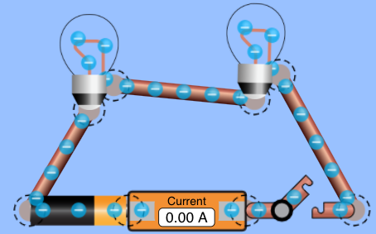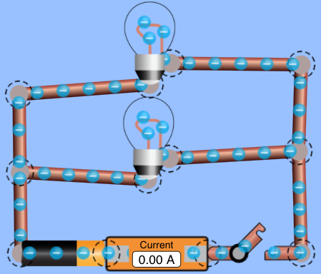
2-bulb series (left), parallel (right)

Q5: Predict first: (a) will the bulbs in series be brighter than the single bulb? No, the single bulb will b brighter
(b) will the bulbs in parallel be brighter than the single bulb?
No, the bulbs will have the same intensity of brightness.
Q6: Test your predictions and comment.

My predictions were correct, bulbs in series were not brighter than the single bulb, the single bulb was brighter. The bulbs in parallel had the same intensity of brightness.

Q7: Compare the total current in the series circuit to the parallel circuit. Which is greater (if any)?
The current in parallel circuit is much greater than current in series circuit as potential difference across each of the resistors is the same and current differs with the size of resistor hence subsequent current flowing through each resistor will be higher.
Q8: What does that say about the total resistance in the series circuit versus the parallel circuit?
It shows that the total resistance in series circuit is higher than in parallel circuit and according to ohms law, the higher the resisatnce, the lower the current flow and the lower the resistance, the higher the current flow.
(one more page with questions)
Q9: In the parallel circuit, try putting an ammeter where one of the bulbs goes. What happens, and why do you think that happens?

The bulbs blows. Ammeters should not be connected in parallel as it will cause a short circuit
In a schematic diagram, symbols are used instead of lifelike pictures. In the pictures below, the symbol on the left represents a battery (long line is the + terminal):

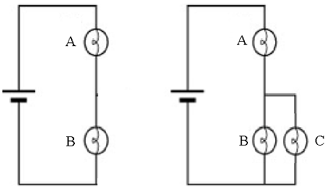

I start with a two-bulb series circuit, and then put in bulb C to be in parallel with B.

Q10: Predict whether A gets brighter, dimmer, or stays the same when I add bulb C. Give reasoning.
The bulb A will remain the same as the introduced bulb is in parallel with bulb B which was in series with bulb A hence no changes will occur with bulb A. If bulb C was connected in series with bulb A then one would observe changes with bulb A i.e. it would start
Final question: try and set this up in the simulator. What happens to bulb A? You can check by putting an ammeter next to it and measuring the current through it. Why do you think this happens?

The bulb A remained the same as the introduced bulb is in parallel with bulb B which was in series with bulb A hence no changes will occur with bulb A. If bulb C was connected in series with bulb A then one would observe changes with bulb A i.e. it would start

